
A14
Sreenidhi Institute of Science & Technology
(An Autonomous Institution)
Code No: 4H112
B. TECH. I – Year I – Semester Examinations, January 2015 (Regular)
MATHEMATICS FOR BIOTECHNOLOGY - I (BT)

Time: 3 Hours Max. Marks: 70

Note: No additional answer sheets will be provided.

Part - A Max.Marks:20

Answer all QUESTIONS.

- Find the value of Sin(1080⁰) and Cos(1110⁰)
- Find Sin36⁰
- Find the Co-Ordinates of Vortex and Focus of the y²=4ax
- Find the angle between 3x + 5y =7, 2x-y=-4
- Find 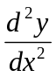 where 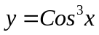
- Find the Equation of tangent to the Curve xy=10 at (2,5)
- Find 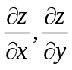 where z=x³ + y³ - 3axy
- Find 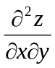 where z= xy + x³y at (1,1)
- Evaluate 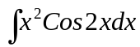
- Find the value of 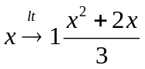
Part – B Max.Marks:50
ANSWER ANY FIVE QUESTIONS. EACH QUESTION CARRIES 10 MARKS.
1 a) Express 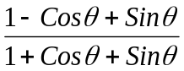 in terms of 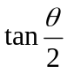

b) Prove that 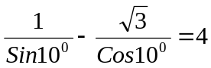

2 a) Find the Eccentricity, foci, Length of latus rectum and equation of directrix of
9x² +16y²-36x+32y-92=0

b) Find the midpoint of the chord interception by 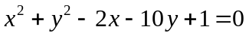 on the line x-2y+7 =0.

3 a) Verify the continuity at x=0 of f(x) = 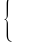1 if x<=0
{ 2 if x>0

b) 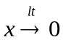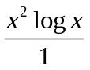

4 a) Find the derivative of 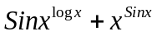

b) Find the derivative of y=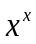

5 a) Find the Length of Sub tangent, Sub Normal at a point ‘t’ on the curve
X= a(Cost +tSint) Y= a (Sint-tCost)

b) Find the Equation of the Normal to the Curve xy=10 at (2,5).

6 a) Evaluate 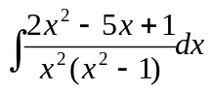

b) Evaluate 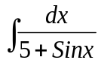

7 a) Show that 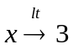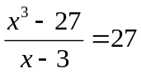

b) Find equation of straight line passing through (0,2) and (2,0).

8 a) Find the Minima and Maxima of 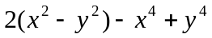

b) if u= xlogxy, where 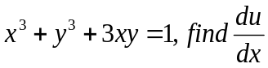

-- 00 -- 00 --

